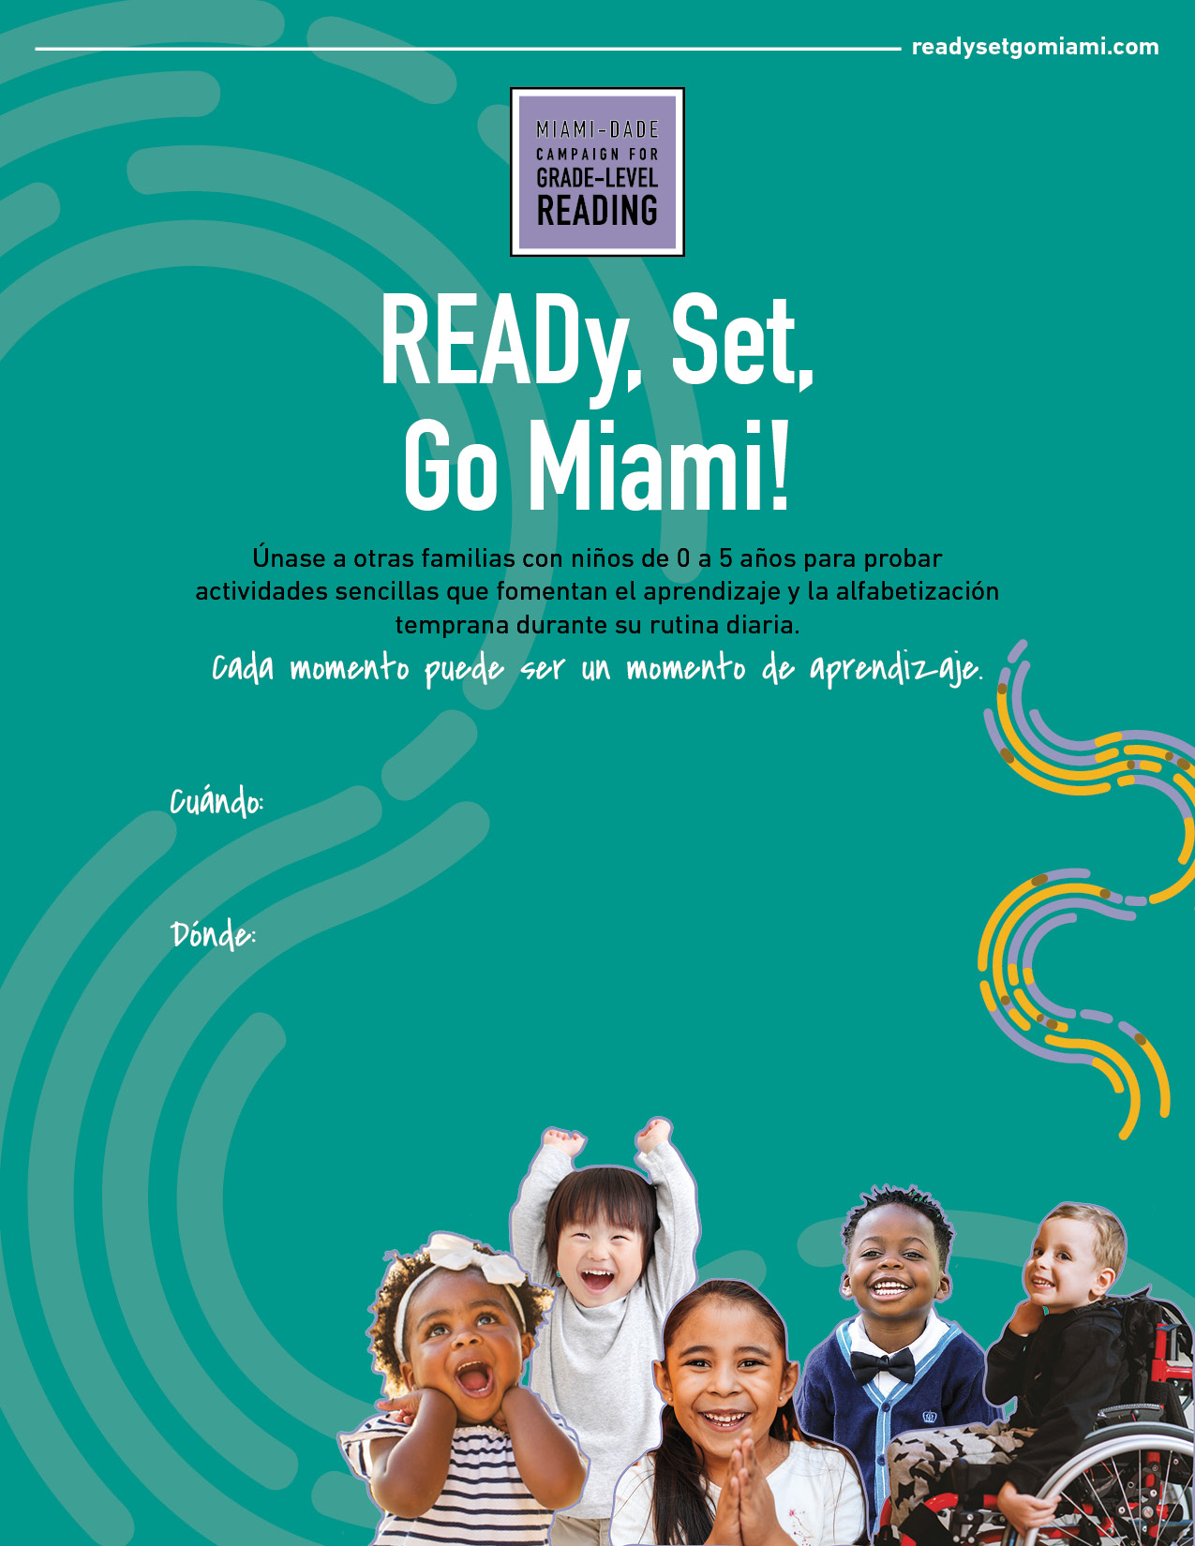

May 1st, 2021
11am – 2pm

Miami-Dade College, Wolfson Campus
222 Miami Ave., Suite 300
Miami, FL 33333

